

University of Asia Pacific

COMPUTER SCIENCE AND ENGINEERING

SOFTWARE DEVELOPMENT LAB

CSE410

ONLINE FOOD ORDER

Student Information:

Name: Joy Dhar

Id: 16201063

Sec: A2

### Contents

**1 ABSTRACT** **2**

**2 INTRODUCTION** **2**

**3 MOTIVATION** **2**

**4 FEATURES** **2**

**5 TOOL’S DESCRIPTION** **3**

**6 WORKING PROCESS** **10**

**7 RESULT** **11**

**8 FUTURE SCOPE** **12**

**9 CONCLUSION** **12**

# ABSTRACT

ONLINE FOOD ORDER is a website designed primarily for use in the food delivery industry. This system will allow hotels and restaurants to increase scope of business by reducing the labor cost involved.

My system will allow restaurants to quickly and easily manage an online menu which customers can browse and use to place orders with just a few clicks.

# 2 INTRODUCTION

# Online Ordering System can be defined as a simple and convenient way for customers to purchase food online, without having to go to the restaurant. This system is enabled by the internet – it is the internet that connects the restaurant or the food company on one hand, and the customer on other hand

# 3 MOTIVATION

Motivation is the reason for people’s actions, willingness and goals. My motivation to work on this project are -

* Makes the ordering process easier. ...
* Efficient customer and order management. ...
* Monitor your expenses incurred in real time. ...
* Free and cheap marketing. ...
* Better customers data. ...
* The convenience of mobile ordering. ...
* Stay ahead of the competition. ...
* Grow your bottom line.

# 4 FEATURES

* Register
* Food Menu
* Food Cart
* Order History Check
* Admin Add Food

# 5 TOOL’S DESCRIPTION

### Homepage

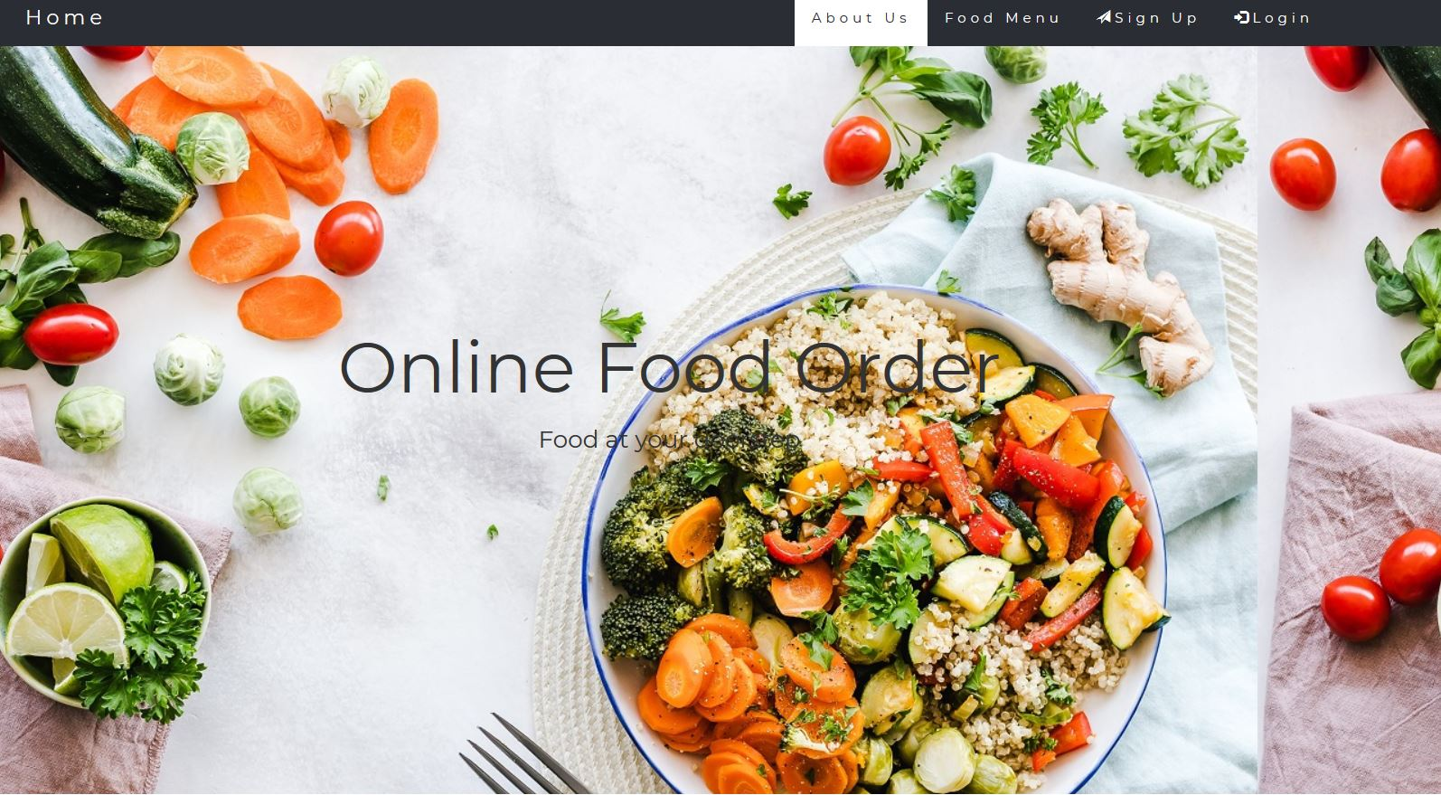

### Services

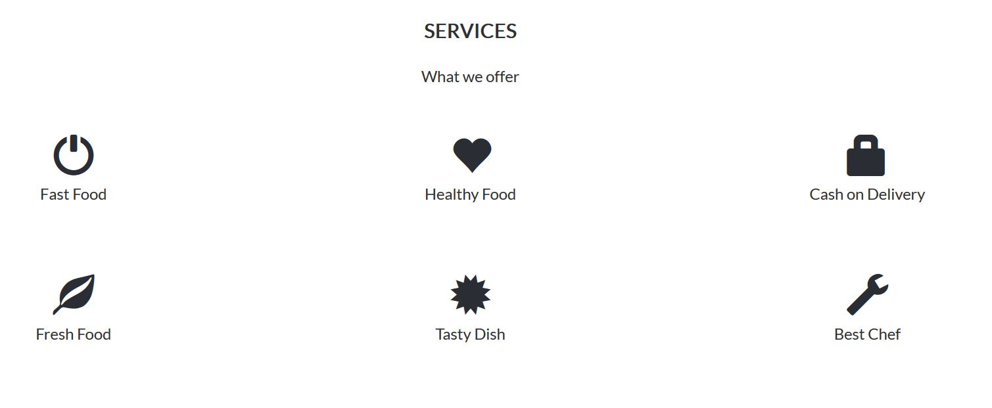

### Sign-up

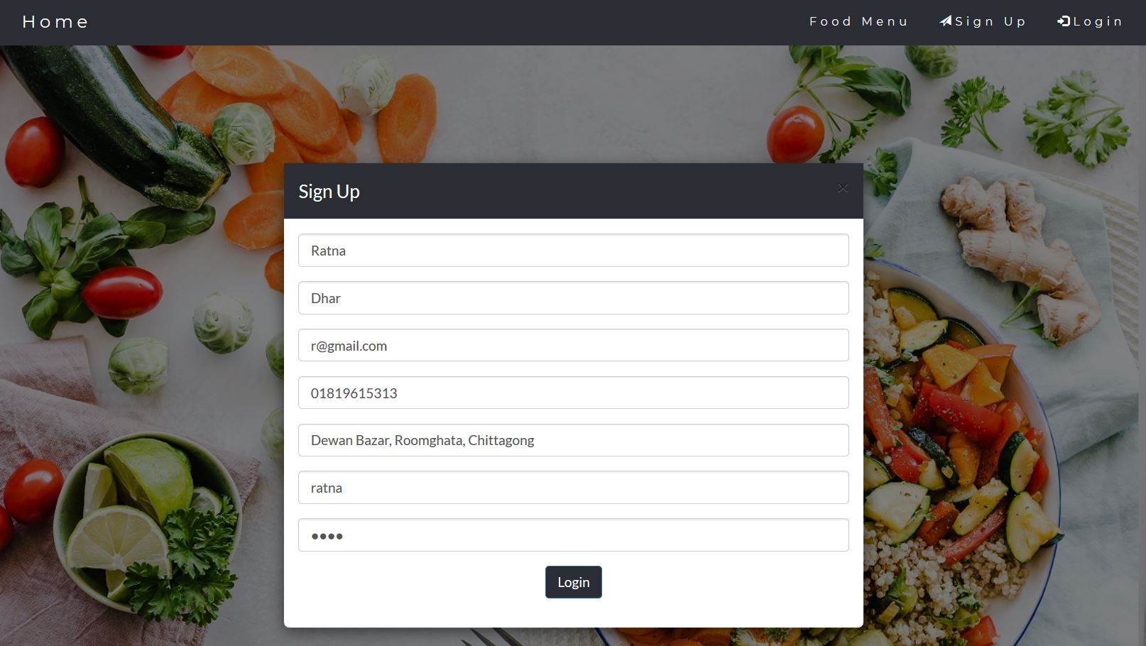

### Sign-up Confirm

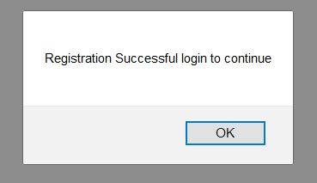

### Log in

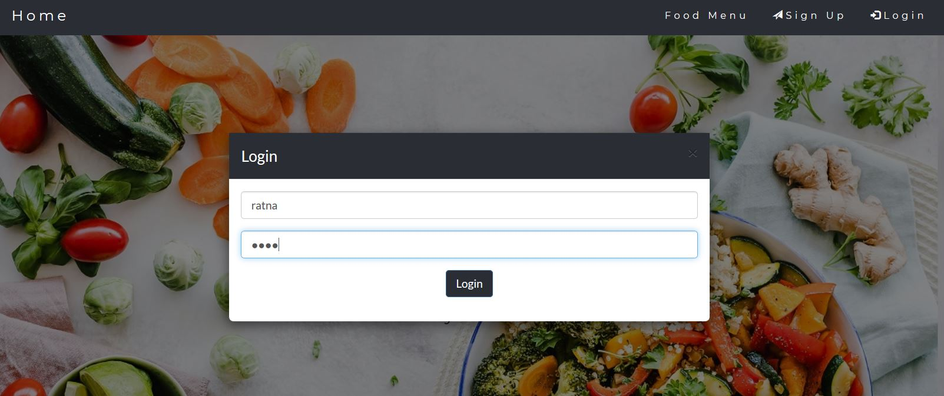

### User Profile

### 

### Food Menu

### 

### Food Cart

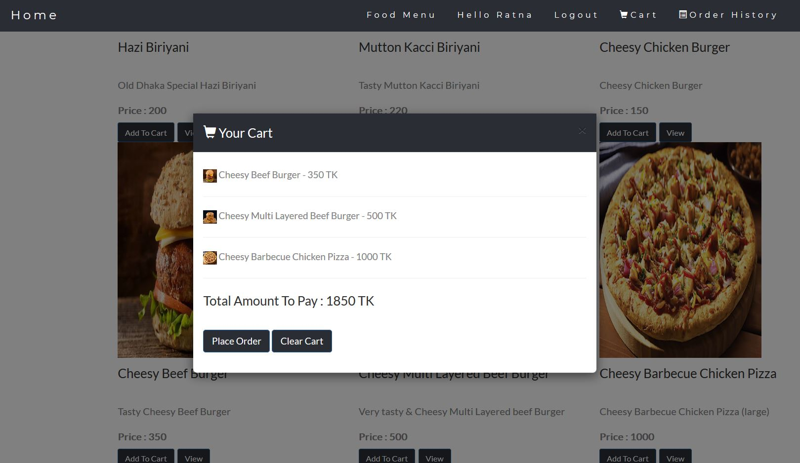

### Oder History

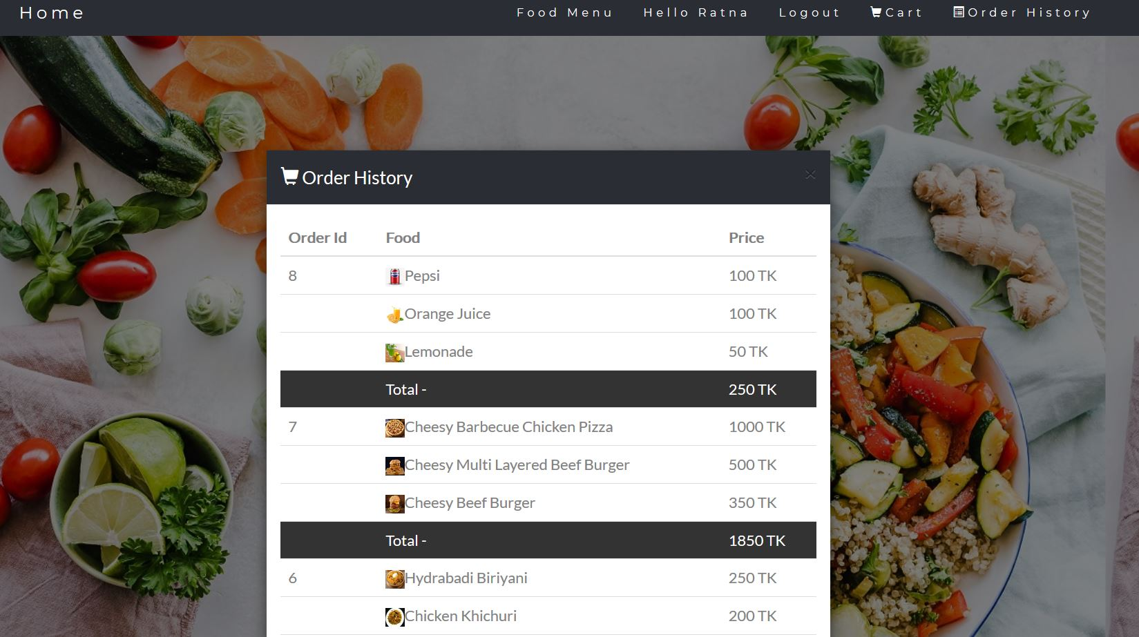

### Order Confirm

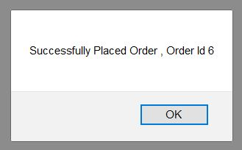

### Admin Login

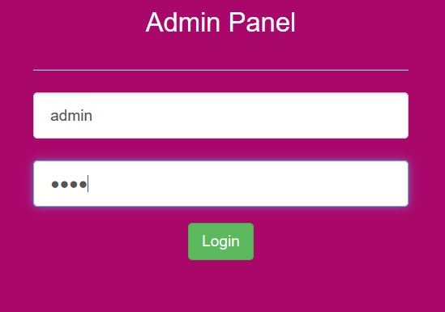

### Admin Add Food

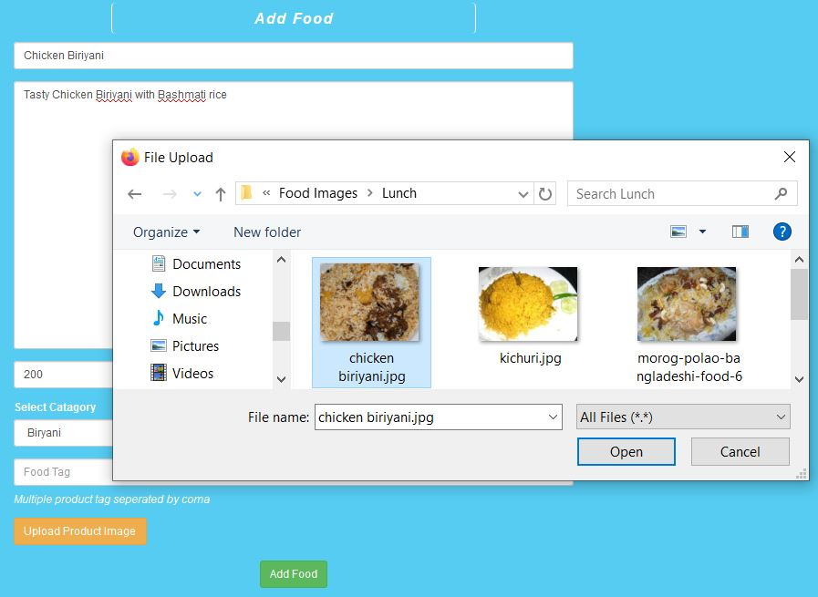

### Mobile View

### 

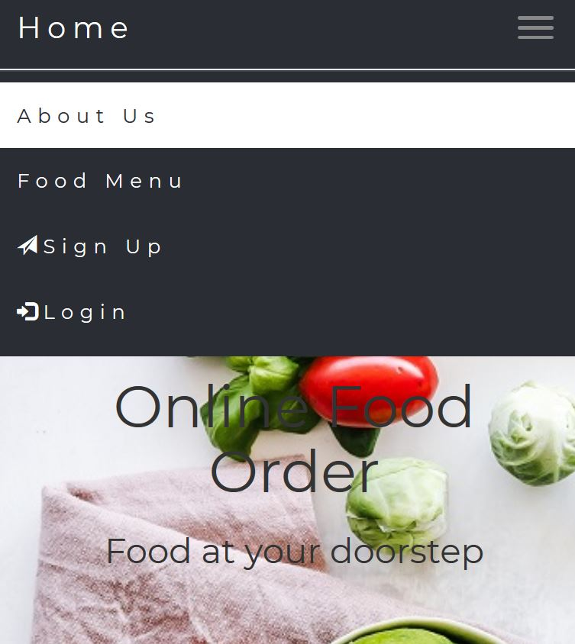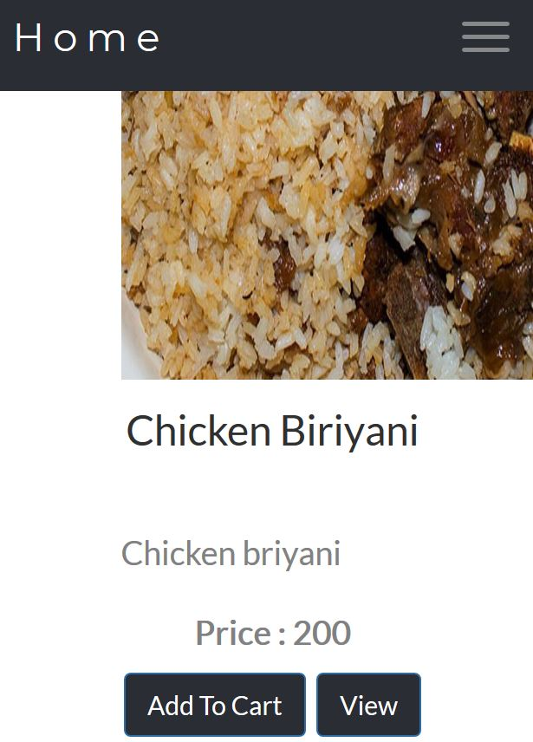

### 6 Working Process

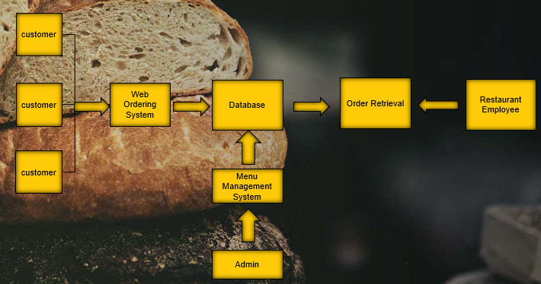

### 7 Result

The result of this project is to make a easy system for food ordering via internet.

### 8 Future Scope

Future of Online Food Ordering Business .It is evident everywhere that the food ordering & delivery sector has a huge scope for online penetration. ... booming sector can reach out to us to learn more about our online food ordering system.

### 9 Conclution

Online ordering on board you will enrichen your customer experience by making the process of 'placing orders' a lot easier. It will show that you value your customer's time. Online ordering will guarantee a 'level up' to your web presence